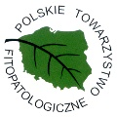
Serdecznie zapraszamy na webinarium Polskiego Towarzystwa Fitopatologicznego

Dr. Jaap D. Janse

Senior bacteriologist, independent consultant, The Netherlands

Four relatively unknown bacterial plant diseases that could be introduced into Poland and/or other parts of Europe: bacterial blight of bean, bacterial blight
of grapevine, bacterial leaf blight of rice and bacterial leaf streak of rice.

30.03.2022 r. o godzinie 13:00
MS TEAMS
Link do spotkania:

